The Mental Health Mechanic (101)

(How to Work Your Mental Health Meter)
Purpose: To help attendees to start to identify stressors and non-stressors (mental health, mental illness alike, situational depression(s), and/or a bad day) so they can better manage their mental health and wellness.

______________________________________________________________________________

What do you think your mental health meter would look like if you were experiencing these symptoms/situations? Use a pencil to fill in your answers, or you can draw your own mental health meters on a blank piece of paper using the three meters below as a model.
Illness/Condition

Situational

Bad Day

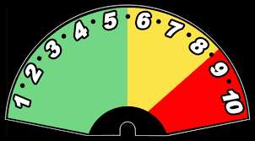

1 = Complete Calm/Peace, 10 = Imminent Crisis
Scenario 1: Your professor wouldn’t give an extension on research paper deadline due tomorrow and you have to work your campus job tonight. Someone cracked your back tail light while pulling out of the campus parking lot and it was a hit and run. Your thoughts have been up and down lately and you can’t seem to enjoy the things you once enjoyed, seemingly for no reason at all. The campus psychiatrist thinks diagnosing you with clinical depression seems appropriate.

Scenario 2: You lost $10 in a bet. You were 15 minutes late for work. You didn’t sleep much the night before. You haven’t eaten much today. You found out that you didn’t get the summer internship you had your heart set on.

Scenario 3: You found out your significant other (girlfriend/boyfriend) of 3 years has been cheating on you and wants to leave you. You both share friends and some are taking the other person’s side.

